Microinjection
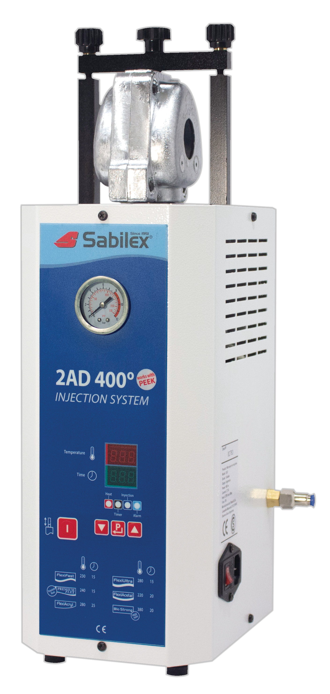
Machine

Sabilex 2AD 400



User´s Guide

Please, read this manual before using the machine.

Thanks for choosing Sabilex to produce quality flexible partials

This manual gives you important information about the use of the injector to create flexible partials and dentures.

About this manual
The information it contains might be changed without advice.
To obtain the most recent information about this product, we recomend to ask your nearest Sabilex distributor.

Statement of ageement
Model : 2AD400
Mark: SABILEX
Responsable: Flexafil S.A.
Address: Leopoldo Marechal 1312 (1414) Buenos Aires – Argentina
Telephone : Tel/fax 54 (11) 4854-4814
This machine is in accordance with the Machinery Directive 2006/42/CE , and the Low Voltage Directive(LVD) 2014/35/EU

œ “CE” mark means this product agree with european security requirements about security, health, environment and client protection.

Contents
Read the following items before using the injector
- Accesories
- Suggestions
- Warning
- Sabilex Microinjection machine operation technique
- Injection unit
- Heating unit
- Closing unit
- Typical cycle to inject partials
- Flexible partial injection technique

1. Accessories

You receive with the machine the following elements:
- A bronze brush and a wood stick to introduce a chamois rag into the cylinder and keep it clean
- One flask
- One release compound lubricant
- Injection cartridges
- Promotional material

2. Suggestions:

- Every time you put the flask into the closing unit, verify it’s well closed
- We suggest preheat the cartridges before using during 30-45 minutes in 90ºC
- Remember: it’s convenient to preheat flask before injecting.
- If you release some gas to the flask, it will improve the injection.
- To remove the flask once you have injected, push the injection valve again.
- Take care the cartridge is not dented, to avoid it get jammed inside the cylinder.
- IMPORTANT: in order to achieve a good operation of the micro injector along the time, we recommend to filter and lubricate the air that is used (put a lubricator filter previous air entrance to the machine)
If you have any doubt about the flask filling or the injection technique, call Flexafil SACI.

3. Warning

Unplug the machine of the electric line and air compressor before doing adjustments or repairing inside the unit. If you have any doubt, contact your nearest distributor.

Use cotton gloves to remove the flask to avoid heat in your hands.

Sabilex microinjection machine is protected with a ground line to avoid electric risk. Be sure your electric installation is effective.

Sabilex microinjection machine must be connected to protected line with fuses.

This machine doesn’t need any preventive maintenance, such as lubrication, etc. if you have any problem, contact an authorized technician.

4. Sabilex Microinjection machine operation technique

The injector consists of 3 units:

- Closing unit

- Heating unit

- Injection unit

ON/OFF switch.
(Right side)

Red Display

Green Display

Advisor Leds

Keyboard

5. Injection Unit

It consists of a pneumatic piston, operated by an air compressor or Nitrogen tube. Minimum pressure required is 7,0 kg/cm³.

6. Heating unit

It consists of a cylinder where the user put the cartridge. The machine heats the tubes by a electric resistance, which are controlled by a digital pyrometer. This part is the one that controls the temperature, according to the selected material.

7. Closing unit

This unit contains the flask and holds it during injection process.

8. INSTRUCTIONS

The new Microinjection machine automatic Sabilex 5 Pro, is most versatile and light of the market. It has a controller who allows to a easy handling and a simple visible interface with the user.
- To ignite the machine push the general key located on the right side, next to the current entrance (220V or 110V).
p
- Push in order to program the desired temperature of injection. In red display, you can observed the message t1, in green display is observed temperature of injection, pressing the keys   we can modify the value of temperature of injection.
- Pushing again in red display, is observed the message of tie, in green display the value of warm up time of the cartridge previous to the injection is observed, by pressing the keys   we can modify the value of the time of heating.
p
- Pressing again, in red display is observed t2, in green display is observed the value of the time in seconds of the piston in the superior position (for example 30 seconds), pressing the keys   we can modify this value.
p
p
- Pushing again and the program is set.

If we made modifications and we did not leave the program by pressing the key , after 30 seconds without touching any key, the new values will not be kept and the machine will return to the reading.
p

- When the machine gets the injection temperature a buzzer sounds. Introduce the cartridge at this moment and push  during 5 seconds; it begins to count to timer the warm up time for the cartridge heating. When the timing is completed, the machine injects automatically and maintains the piston the programmed time, after which the piston goes down.
- It appears Fin in green display and the resistance stops heating. This indicates that the cycle of injection has finished.
- If you want to restart the cycle, push   simultaneously and the machine will begin to warm up again.
- To move the piston independent of the cycle, push and the piston will go up. Push it again and the piston will go down.
I

Advise Leds

Heat Injection

1
21
321
421

Timer Alarm

- LED1: Indicates that resistance is heating
- LED2: Indicates that the timer is controlling the heating time
- LED3: Indicates that the piston is going up.
- LED4: Alarm. It turns on if there is any cause that interrupts the cycle.

Injection cycle without using the timer

If, for any reason, you want to do a manual injection, proceed as follows:
- Turn the machine ON by pushing the ON/OFF button.
- Program the injection temperature (see Instructions on page 5).
- Program the heating time in 0 (zero).
- If the cycle was already programed, the machine will control normally the temperature with the information set before.
- When the machine reaches the programmed temperature, put the tube inside the cylinder and wait 15 minutes.
I
- Push the button for the piston to go up.
I
- Wait for 35 seconds and push the button again for the piston to go down.
- Remove the flask.

9. Injection cycle without using the timer

- Once you have your original cast model from the dentist, take care it get to the end of the groove. (Picture 1). Prepare a 2nd copy of the model.
- Watch the picture 2 by where you should alleviate and remove false square, alleviate to all soft tissue, specially the cervico gingivo distal areas and mesial gingival cervical areas and eliminate the retentive areas of the teeth without invading the oclusal or incisal third of he himself. Once you finalized the work, make its duplicate.
- Make the duplicate with reproduction jelly, soaking the model completely by 10 minutes. Passed this time proceed to duplicate the model.
- Figure 3 shows to a conventional base plate with its buns to send to the professional.
- Once received the work with its bite and antagonist, putt it in oclusor or articulator, as it shows figure 4.
- Consider that when we lined up, do not wear away too much the heel of the tooth, since this one needs its retentions by mesial, distal and oclusal sides, as it shows figure 5.
- Proceed with the waxing and design of the denture. The waxing should be thin and fine, minimum 0.3 mm. (special waxes are not required).
- Take the waxing to the cíngulum of the previous teeth, as it shows figure 6.
- By the vestibular part of the tooth, take the waxing of the clasp 2mm by above of the gingival part as it shows figure 7.
- Trim the teeth until its waxing, to avoid the teeth to be retained in the flask, as it shows figure 8.
- Trim the model with the Thimmer machine to avoid retentive areas, as it shows figure 9.
- Observe in figure 10 the putting in muffle, alleviating with plaster its retentive areas.
- Figure 11 shows the bolt of entrance, that it’s a wax leaf, and with wax “utility” to cover the entrance orifice.
- Once made the previous step, place the contra flask, locating two screws only in its ends.
- Proceed to conventional washing removing the screws previously.
- Once washing was done correctly, put pink separator in flask and contra flask, close it with its 4 screws affluent fit and proceed to the injection (to see “Instructions in page 5”).
- Figure 12 shows the injected flask.
- To open to the flask, remove the 4 screws and strik with a hammer the superior part, as it shows figure 13.
- Figure 14 shows a correct injection, eliminating therefore the plaster of the denture and taken care by far of not hurting the clasps.
- To eliminate the bolt of entrance with a metal disc, as it is observed in figure 15.
- Once eliminated the entrance bolt, scrape the denture with an acrylic stone or grinder, as it shows figura16.
- Clear the edge parts and eliminate with a cylindrical rubber as in figure 17.
- As it is observed in figure 18, polish the denture with a brush of 4 or 5 rows with pumice paste.
- With a sheepskin or rag, give brightness to the denture with its corresponding paste, as it is seen in figure 19.
- Figure 20 shows the finalized work, located in its original model, ready to give to the professional.

MICROINJECTOR SABILEX
Troubleshooting guide:
Problem | Cause | Solution
1) When you turn on the injection machine, the temperature controller doesn’t work | The fuse is damaged | Replace the fuse.
2) When you turn on the injector the temperature controller doesn’t increase temperature | The heating-element got burned | - Replace the heating-element
3) When you heat the tube, the cup pops out  o | The material got moisture | Pre-heat the material for 5 hours at 60ºC
4) The cavity in the flask doesn’t get filled. | - Slender injection channels  - Low injection pressure  - Air volume insufficient | - Enlarge the injection channels  - Check the minimum pressure:7 kg/cm³  - Check the feeding pipe doesn’t have the filter or any other part obstructed  - Try to take out the air filter and inject. If the injection is correct, the filter is dirty or obstructed. Replace the filter.
5) The material crystallizes and breaks | the injection was made with the flask cold | Pre-heat the flask before injecting.  Suggestion: put the flask on a heat resistant ceramic over the oven and cover it.

